Themenblock 3: HOLIDAYS & TRAVELLING
CATEGORY A: CONTRASTING IMAGES
TASK SET A1: Group Tours vs. Independent Travel
PART 1 — Individual Long Turn
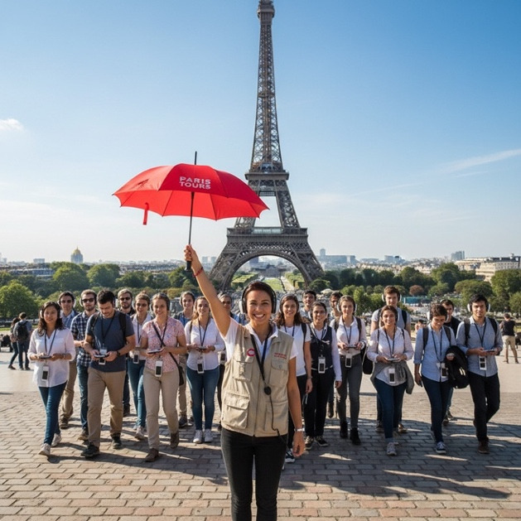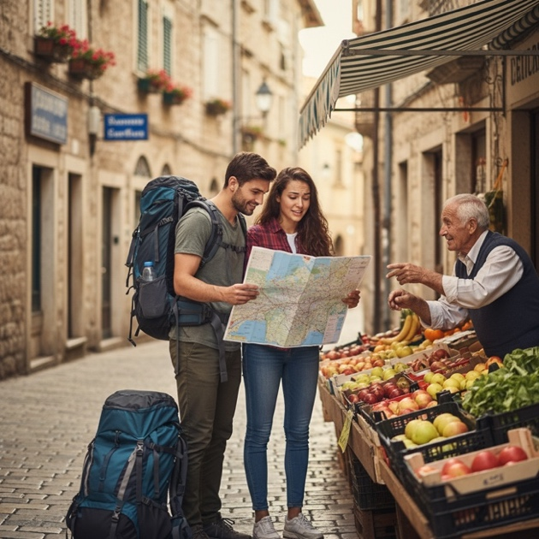
Task:
Give a five-minute talk on different ways of travelling in which you
- describe, compare and contrast the two pictures above.
- evaluate the advantages and disadvantages of organized tours versus independent travel.
- discuss which travel style suits you best and explain why.
PART 2 — Paired Activity
Task:
Your school is organizing a week-long class trip abroad for final-year students. You and your partner are on the planning committee and need to decide on the type of trip. Discuss the following options and agree on two:
- All-inclusive package tour with professional guide
- Self-planned itinerary with student-led exploration
- Combination of organized activities and free time
- Homestay program with local families
- Adventure travel with outdoor activities

TASK SET A2: Tourist Hotspots vs. Authentic Experiences
PART 1 — Individual Long Turn
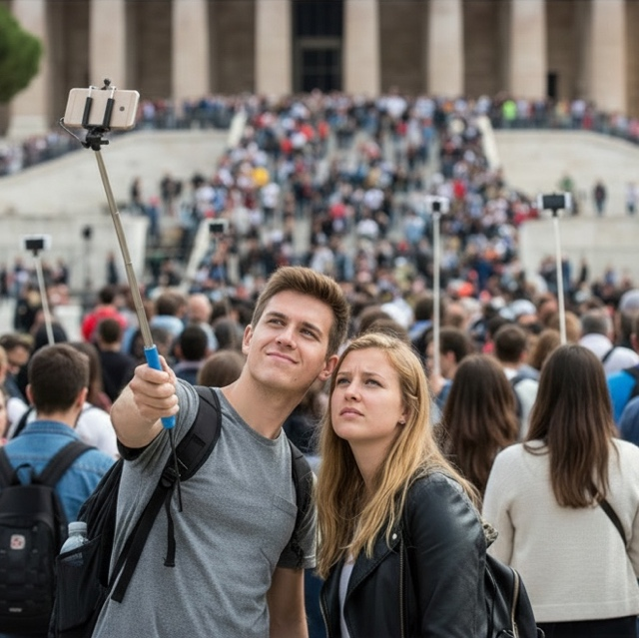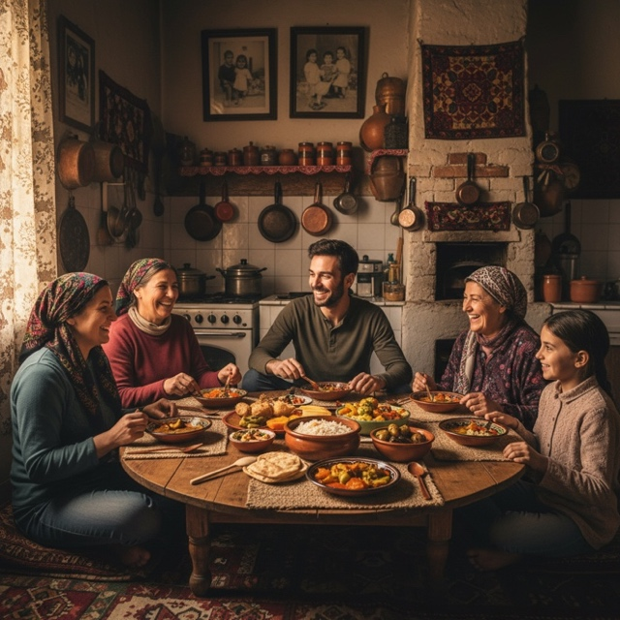
Task:
Give a five-minute talk on authentic travel experiences in which you
- describe, compare and contrast the two pictures above.
- analyze the impact of social media on how people travel today.
- comment on what makes a travel experience truly meaningful to you.
PART 2 — Paired Activity
Task:
A travel magazine has asked students to contribute ideas for an article called "Beyond the Selfie: How to Travel More Meaningfully." Discuss the tips below and agree on three:
- Put your phone away for at least one hour each day
- Choose one lesser-known destination instead of tourist hotspots
- Learn basic phrases in the local language before you go
- Eat where locals eat, not in tourist restaurants
- Spend time talking to residents about their daily lives

TASK SET A3: Overtourism vs. Sustainable Travel
PART 1 — Individual Long Turn
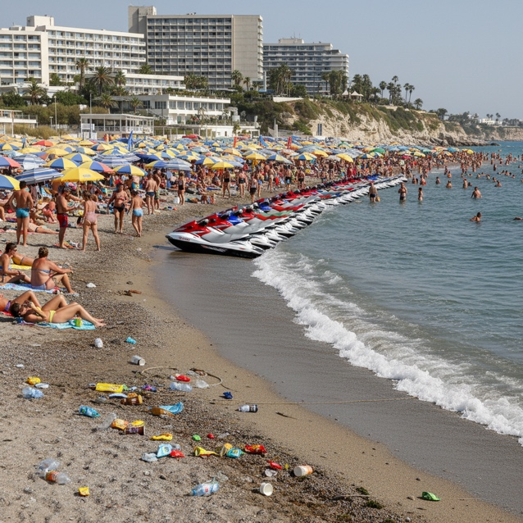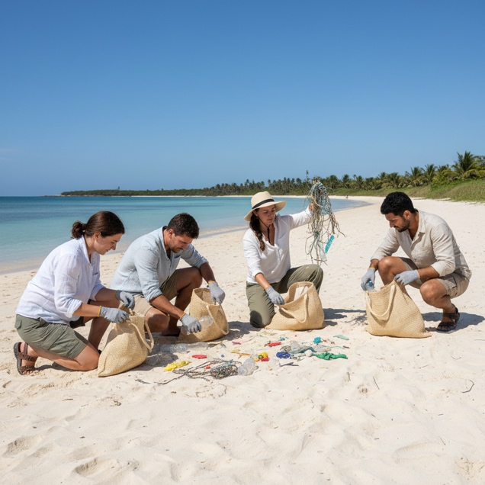
Task:
Give a five-minute talk on tourism and environmental responsibility in which you
- describe, compare and contrast the two pictures above.
- evaluate the environmental consequences of mass tourism on popular destinations.
- suggest ways in which travelers can minimize their negative impact while still enjoying their holidays.
PART 2 — Paired Activity
Task:
Your town has become an increasingly popular tourist destination, and residents are concerned about the environmental and social impact. The local council has asked for youth input. Before meeting with the council, discuss the following measures and agree on three to propose:
- Limit visitor numbers to sensitive natural areas through a reservation system
- Require all tour operators to obtain eco-certification
- Create a 'sustainable tourism pledge' for visitors to sign upon arrival
- Invest tourism tax revenue directly into environmental restoration projects
- Promote off-season travel through discounts and special events

CATEGORY B: QUOTES
TASK SET B1: Tourists vs. Travelers
PART 1 — Individual Long Turn
Quote 1:
"Tourists don't know where they've been, travelers don't know where they're going."
— Paul Theroux, The Tao of Travel (2011)
Quote 2:
"Travel is intensified living ... and one of the last great sources of legal adventure."
— Rick Steves, Europe Through the Back Door (2015)
Task:
Give a five-minute talk on different approaches to travel in which you
- critically analyze both quotes and explain what each suggests about the travel experience.
- discuss whether there is a meaningful difference between being a 'tourist' and being a 'traveler.'
- describe a travel experience where you felt like a genuine traveler rather than just a tourist.
PART 2 — Paired Activity
Task:
Your school wants to encourage students to travel more meaningfully. You are creating a list of "Travel Resolutions" for a school display. Discuss the options below and agree on three:
- Keep a detailed travel journal rather than just taking photos
- Travel to at least one country where you don't speak the language
- Volunteer abroad for at least one week
- Travel slowly — stay longer in fewer places
- Challenge yourself to try one thing that scares you on each trip

TASK SET B2: The Journey of Self-Discovery
PART 1 — Individual Long Turn
Quote 1:
"We travel, initially, to lose ourselves; and we travel, next, to find ourselves."
— Pico Iyer, "Why We Travel" essay, Salon (2000)
Quote 2:
"You go away for a long time and return a different person — you never come all the way back."
— Paul Theroux, Dark Star Safari (2002)
Task:
Give a five-minute talk on travel and self-discovery in which you
- analyze and compare the messages in the two quotes above.
- discuss how travel can change a person's perspective on their own life and identity.
- outline what young people can learn about themselves through travel experiences.
PART 2 — Paired Activity
Task:
Your school is launching a 'Gap Year Guidance' program for students considering time off before university. Discuss the options below and agree on two types of gap year experiences to recommend:
- Backpacking through multiple countries on a budget
- Working holiday visa in Australia or New Zealand
- Volunteering with an international NGO
- Language immersion program in a non-English speaking country
- Interrail pass across Europe with structured study component

CATEGORY C: ALTERNATIVE PROMPTS
TASK SET C1: The Global Tourism Boom
PART 1 — Individual Long Turn
Text Extract:
"Global tourism has fully recovered from the pandemic. According to the UN World Tourism Organization, an estimated 1.4 billion international tourists travelled in 2024, marking a complete recovery to 99% of pre-pandemic levels. This represents an 11% increase over 2023. The Middle East led the recovery with arrivals 32% above 2019 levels, while Europe and Africa also exceeded pre-pandemic numbers. Growth is expected to continue at 3-5% in 2025, contributing significantly to global GDP and employment — tourism accounts for approximately 3% of world GDP directly and supports hundreds of millions of jobs worldwide."
— Source: UN Tourism World Tourism Barometer, January 2025
Task:
Give a five-minute talk on the growth of global tourism in which you
- explain what the statistics reveal about global tourism trends and their significance.
- evaluate both the benefits and challenges of this tourism growth for destinations worldwide.
- comment on how tourism has affected a place you know or have visited.
PART 2 — Paired Activity
Task:
Your city council is concerned about managing increasing tourist numbers. As youth representatives, discuss the measures below and agree on two that would be most beneficial:
- Introduce timed entry tickets for popular attractions
- Create a 'tourist tax' on overnight stays to fund local infrastructure
- Develop and promote alternative, lesser-known attractions
- Limit the number of short-term holiday rentals (Airbnb)
- Launch campaigns encouraging off-season travel

TASK SET C2: The Carbon Cost of Travel
PART 1 — Individual Long Turn
Text Extract:
"A comprehensive study reveals that tourism accounts for nearly 9% of global greenhouse gas emissions — and the sector's carbon footprint has been growing more than twice as fast as the rest of the world economy. Between 2009 and 2019, tourism emissions increased by 3.5% annually compared to 1.5% for global emissions overall. Aviation alone accounts for 21% of tourism's carbon footprint, with private vehicle use adding another 17%. Just 20 countries are responsible for three-quarters of all tourism emissions. Without urgent action, tourism emissions are projected to double every 20 years."
— Source: Nature Communications / University of Queensland study, December 2024
Task:
Give a five-minute talk on sustainable travel in which you
- analyze what the statistics reveal about tourism's environmental impact.
- discuss the dilemma between wanting to travel and protecting the environment.
- suggest practical ways travelers can reduce their carbon footprint.
PART 2 — Paired Activity
Task:
Your school wants to create a "Green Travel Pledge" for students and staff planning trips. Discuss the commitments below and agree on three to include:
- Choose train travel over flying for any journey under 6 hours
- Offset the carbon emissions from any flight taken
- Stay in eco-certified accommodations when possible
- Pack light to reduce aircraft fuel consumption
- Support local businesses and avoid international chains

